EDA Report

EDA
Exploratory Data Analysis (EDA) is the critical first step in machine learning where you analyze, summarize, and visualize a dataset to understand its core structure before building any predictive models.

Objectives:
- Data Cleaning
- Checking Missing Values
- Descriptive Statics on Numerical Columns
- Outlier Analysis
- Co-relation Analysis
- Pattern Recognition

About Data:
The sinking of the Titanic is one of the most infamous shipwrecks in history. On April 15, 1912, during her maiden voyage, the widely considered “unsinkable” RMS Titanic sank after colliding with an iceberg. Unfortunately, there weren’t enough lifeboats for everyone on board, resulting in the death of 1502 out of 2224 passengers and crew.
While there was some element of luck involved in surviving, it seems some groups of people were more likely to survive than others.

Source:
Data have been downloaded from following link:
Data Set Link

Data Dictionary:

Variable | Description
survival | Survival: 0 = No, 1 = Yes
pclass | Ticket class: 1 = 1st, 2 = 2nd, 3 = 3rd
sex | Sex
age | Age in years
sibsp | Number of siblings / spouses aboard the Titanic
parch | Number of parents / children aboard the Titanic
ticket | Ticket number
fare | Passenger fare
cabin | Cabin number
embarked | Port of Embarkation: C = Cherbourg, Q = Queenstown, S = Southampton

Data Description:
- Data have 891 Rows & 12 Columns.
- Column Names are Following:
- 'PassengerId'
- 'Survived'
- 'Pclass'
- 'Name'
- 'Sex'
- 'Age'
- 'SibSp'
- 'Parch’
- 'Ticket'
- 'Fare'
- 'Cabin'
- 'Embarked'
- Data have NO Duplicated values.

Categorizing Columns:
We can categorize these Column into:
- Numeric: [PassengerId, Age, Fare]
- Categorical: [Survived, Pclass, Sex, Sibsp, Parch, Embarked]
- Other: [Name, Ticket, Cabin]

Distribution of Data:
Distribution analysis proves that:
- Age is normally distributed
- Fare is Right Skewed
- 61.6% passengers survived.
- 38.4% passengers passed.
- 55.1% passengers travelled in 1st Class
- 24.2% passengers travelled in 3rd Class
- 20.7% passengers travelled in 2nd Class
- 64.8% passengers were Male.
- 35.2% passengers were Female.
- 76.1% people Travelled without parents and children.
- 68% people Travelled without Siblings and Spouse.
- 74.2% embarked from Southampton Port.
- 18.9% embarked from Cherbourg Port.
- 8.7% embarked from Queenstown Port.

Feature Engineering:
- Name Column was divided into Title and Surname Columns.
- Cabin Column was broken in to Deck column.

Relationship Analysis:
Investigation on relationships between features identifies that:
- 74.2% Females and 18.8% Males survived.
- 25.7% Females and 81.2% Male passed.
- Those who paid higher Fare have higher survival rate.
- 1st class passengers survived most.
- 445 people who were without parents or children died.
- 233 people who were without parents or children Survived.
- Passengers embarked from Cherbourg survived most (about 66.3%).
- Passengers embarked from Southampton died most (about 55.3%).
- Passengers on Deck ‘D’ survived most (75.7%).
- Passengers on Deck ’T’ Died most (100%).
- Most males were in 3rd class and most females were in 1st class.
- More females survived in all classes then males.

Outlier Analysis:
Outlier Analysis identifies that:
- Outliers in Age are due to more distribution of age data, when we check data all ages are valid so, we don’t need to remove these outliers.
- Outliers in Fare are due to following reasons:
- Fare contains combined fare of every family.
- Difference between Fares of each class.

Missing Values:
Following Columns have missing values due incomplete data:
- Age
- Cabin
- Deck

Main Key Findings:
Following are my main key findings from EDA:
- Female passengers have higher survival rate than male passengers.
- 1st class passengers have higher survival rate than 3rd passengers
- Passengers traveling with a small number of family members tended to have better survival rates than those traveling alone or with very large families.
- Passengers paying higher fares had higher survival rates.
- Passengers from Cherbourg had higher survival than from Southampton.

Improvements for Next Iteration:
Here are some improvements for next time:
- Use Data set with more records.
- Dive deep into ‘Name’, ‘Cabin’ & ‘Ticket’ Columns.
- Crete new “individualFare” Column and Explore it
- Crete new “familySize” Column and Explore it.
- Find more relations between survived and other features.

Visuals:
Some visuals from note book are following:
- Pie plot for survived (1) and passed (0):
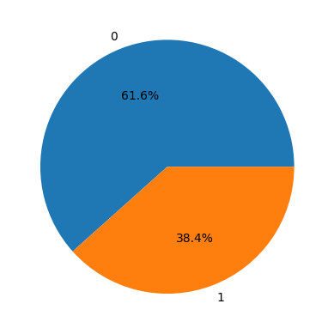
- 2D kde for age VS survival:
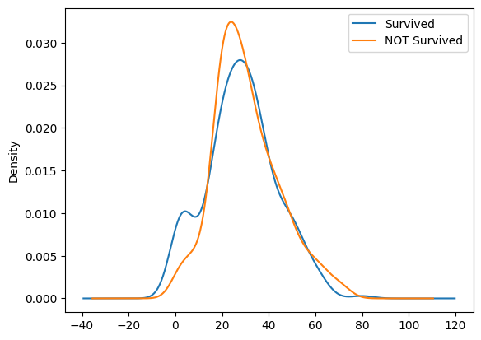
- Villon Plot for age VS sex VS fare
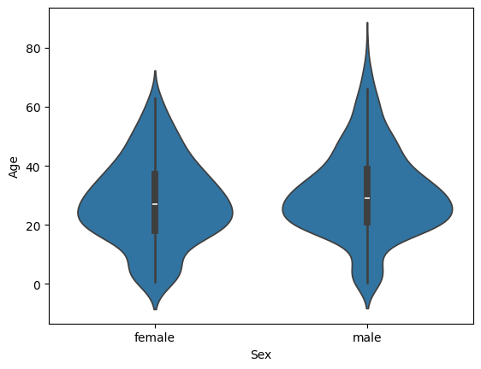
- Co-relation Heatmap:
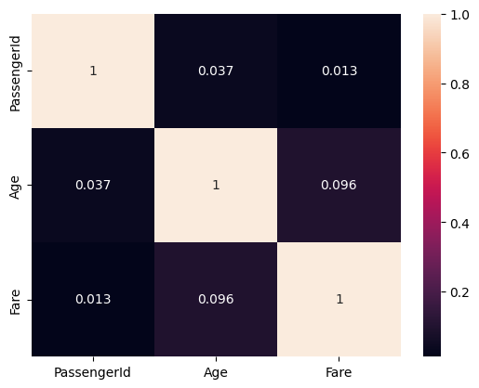
Note: For More Visual Please check out note book.

Code:

Language:
“Python”

Libraries used:
- Pandas
- Numpy
- Matplotlib.pyplot
- Seaborn

Notebook Link:

About Author:
[Git Hub]: Muhammad Sudais Amin | Git Hub
[Linked in]: Muhammad Sudais Amin | LinkedIn

‘

